PROPOSED TITLE

**Pentackles**

FIELD OF INVENTION

* Healthcare Technology/Digital Health
* Combines technology and digital tools to improve healthcare delivery and patient outcomes
* Proposed system uses machine learning to predict disease based on symptoms and provide precautionary measures.
* Aims to address limitations of existing models by predicting multiple diseases simultaneously and considering more parameters for increased accuracy

BACKGROUND

* **Early detection**: Pentackles can help in the early detection of the disease, which can significantly improve the chances of successful treatment and reduce the risk of serious complications.
* **Cost-effective**: ML-based heart disease prediction systems are cost-effective compared to traditional diagnostic methods, as they can analyse a large amount of data in a short time and provide accurate predictions.
* **Personalized medicine**: A heart disease prediction system can provide personalized medicine by analysing the patient's medical history, lifestyle, and genetic information to predict the risk of heart disease and recommend appropriate treatment.
* **Improved patient outcomes**: Pentackles can improve patient outcomes by identifying patients at high risk of heart disease and providing preventive interventions and lifestyle recommendations to reduce their risk.
* **Research**: A heart disease prediction system can help in research by analysing large datasets of patient information and identifying patterns and risk factors that can be used to develop new treatments and preventive strategies.

OBJECTIVE

* The main objective of Pentackles is to accurately predict the risk of heart disease in patients based on various risk factors such as age, gender, family history, lifestyle habits, and medical history.
* This project includes a website which will predict the most possible diseases based on the given symptoms by the user and precautionary measures required to avoid the aggression of diseases.
* The main motive of the proposed system is the prediction of the commonly occurring diseases in the early phase as when they are not checked.

DIAGRAMS

**Data flow diagrams-**

Level 0-

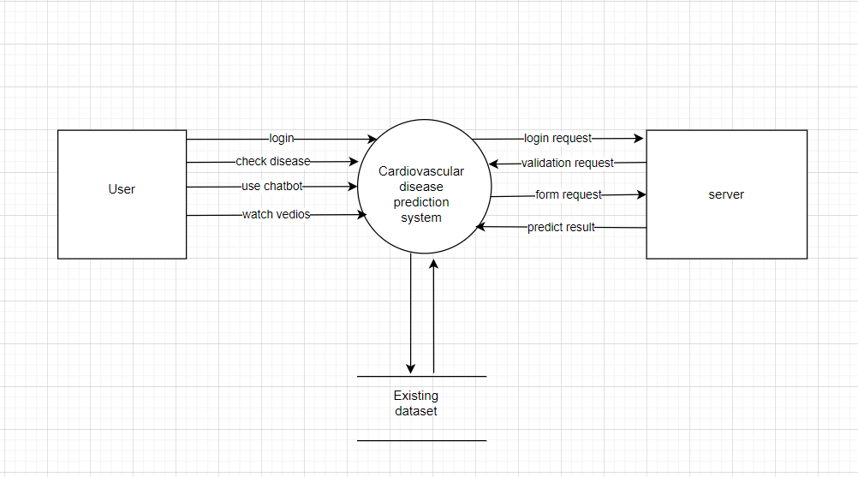

Level 1-

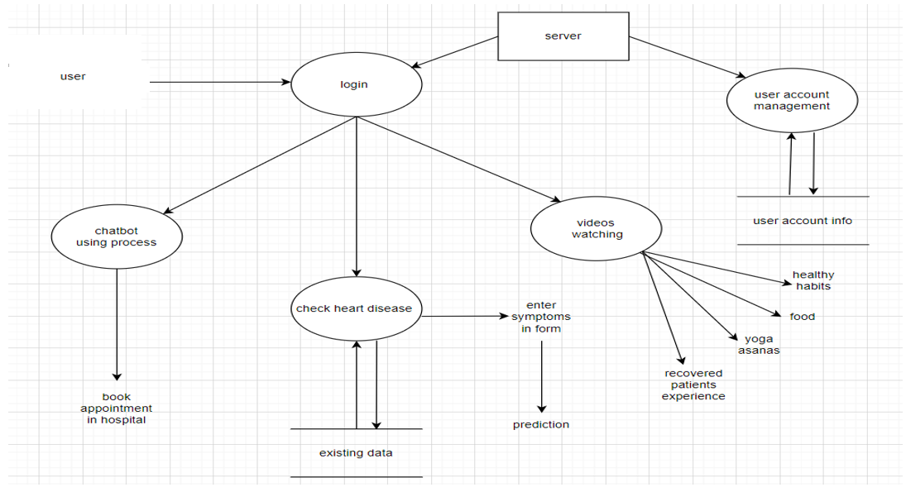

Level 2

**Login**

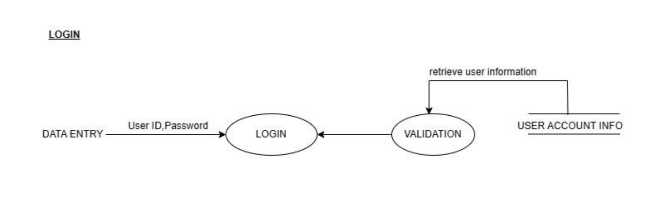

**User Account Management**

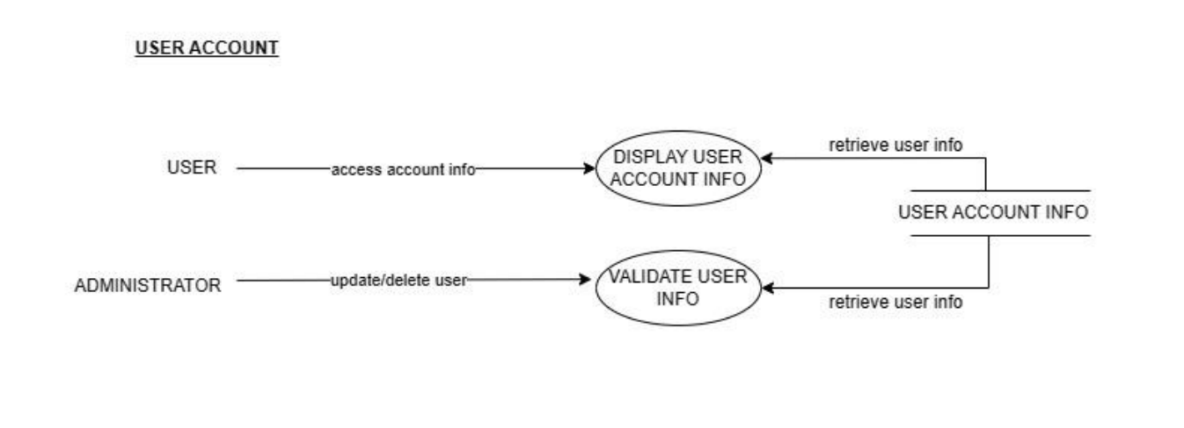

**Chatbot module management**

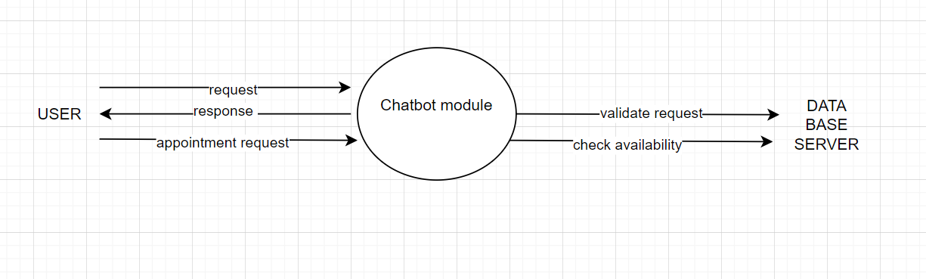

**Videos module**

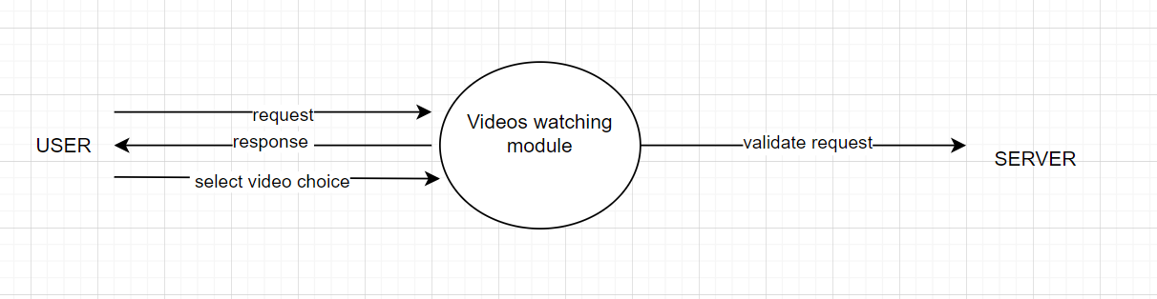

**Prediction module process**

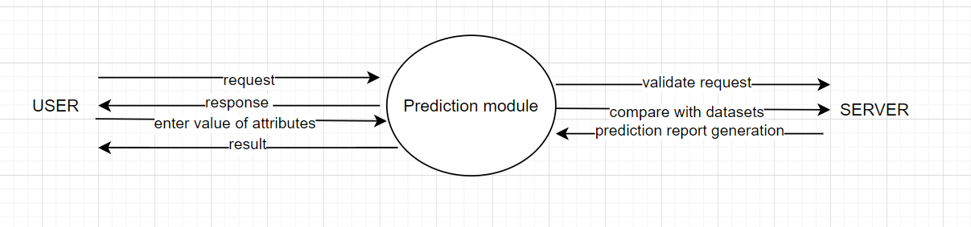

**Flow Chart-**

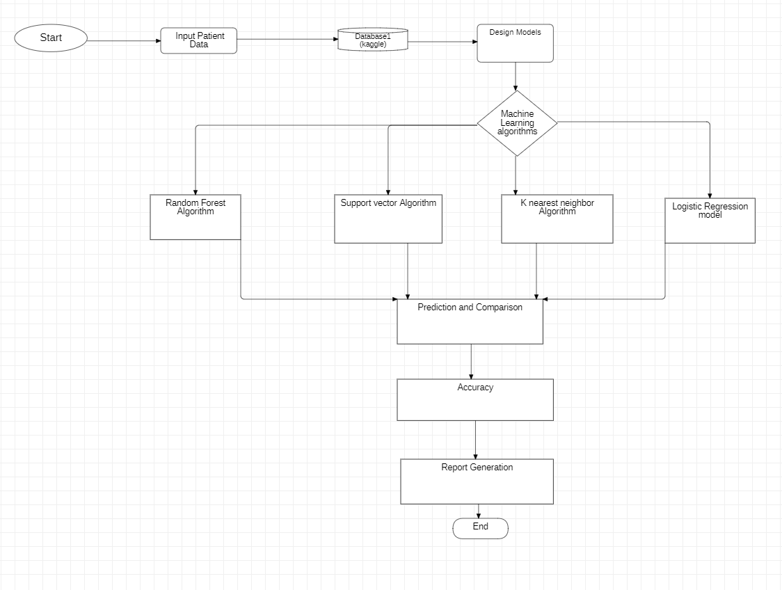

CLAIMS

* **Improved accuracy**: Pentackles can provide more accurate predictions of heart disease risk than traditional risk assessment methods, such as the Framingham Risk Score. This is because ML algorithms can analyse large amounts of patient data and identify complex patterns and risk factors that may not be readily apparent to human clinicians.
* **Early detection**: Pentackles can detect the early signs of heart disease, allowing for early intervention and treatment, which can improve patient outcomes and reduce healthcare costs.
* **Personalized medicine**: Pentackles can provide personalized recommendations for patients based on their individual risk factors and medical history, which can improve patient adherence to treatment and reduce the risk of adverse events.
* **Improved population health**: Pentackles ML can help identify populations at high risk of heart disease and target preventive interventions, such as lifestyle changes or medication, to reduce the incidence of heart disease and improve population health.
* **Cost-effective**: Pentackles can be cost-effective compared to traditional diagnostic methods, as it can analyse a large amount of data in a short time and provide accurate predictions, which can reduce the need for expensive diagnostic tests and interventions.

TECHNOLOGY USED

**FRONTEND**

* Hypertext Markup language (HTML)
* Cascading Style Sheet (CSS)
* JavaScript (JS)
* Bootstrap

**BACKEND**

* FLASK
* Python (Numpy, Pandas, Seaborn, Matplotlib)

**Machine Learning**

* Support Vector Machine (SVM)
* Random Forest
* Logistic Regression
* K Nearest Neighbors (KNN)

ABSTRACT

Machine learning and Artificial Intelligence is playing a huge role in today’s world. The medical industry generates a huge amount of patient data which can be processed in a lot of ways. So, with the help of machine learning, we have created a Prediction System that can detect more than one disease at a time. This project can help a lot of people as one can monitor the persons’ condition and take the necessary precautions thus increasing the life expectancy.

END USERS

* Patients
* Healthcare Providers
* Insurance Companies
* Public Health Officials
* Researchers

ADVANTAGES

* **Accessibility**: Pentackles provide patients with access to healthcare services and information from anywhere with an internet connection.
* **Convenience**: Patients can communicate with healthcare providers, access medical records, and receive medical advice from the comfort of their own homes.
* **Timely Intervention**: Pentackles can provide patients with timely intervention to prevent the escalation of chronic diseases.

CONCLUSION

In conclusion, a heart disease prediction system using machine learning (ML) has the potential to improve the accuracy and early detection of heart disease, provide personalized recommendations for patients, and ultimately improve patient outcomes and population health. By leveraging large amounts of patient data and identifying complex patterns and risk factors, ML algorithms can help clinicians make better decisions and provide targeted preventive interventions. However, it is important to note that any heart disease prediction system using ML should be developed and validated through rigorous clinical studies, and used in conjunction with standard clinical practice. With the proper development, validation, and integration into clinical practice, a heart disease prediction system using ML can be a powerful tool in the fight against heart disease.